Accessibility Guide for Blacksmiths Cottage

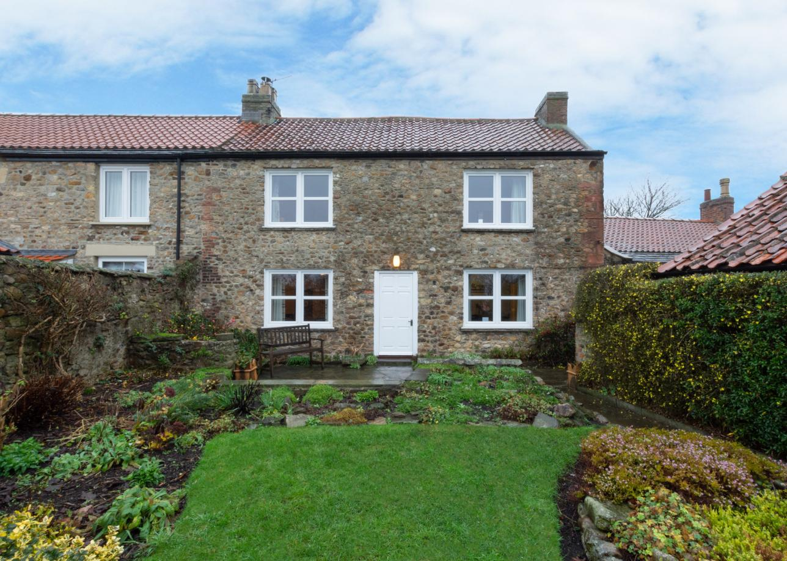

Contacts for accessibility enquiries:
Julie Cockcroft
Mobile: 07825415817
E-mail: Julie_cockcroft@hotmail.com

Welcome
The cottage is located on High Green in Catterick Village
The entrance driveway is via a small track along High Green and is surrounded by a stone wall.
The drive is slightly sloping down from the track and has a solid concrete finish.
The main parking area is on the drive, there is space for 2 cars.

At a Glance
- The main entrance has 1 step. There is no lift and no ramp.
- Bedrooms are located on the 1st floor
- Kitchen, lounge and snug are located on the ground floor
- Bathroom located on 1st Floor
- Toilet located on the ground floor

Getting here
6 High Green
Catterick
Richmond
DL10 7LN

- The nearest bus stop is approximately 200 yards away.
- The nearest train station is Darlington or Northallerton, approximately 12 miles away.

Parking

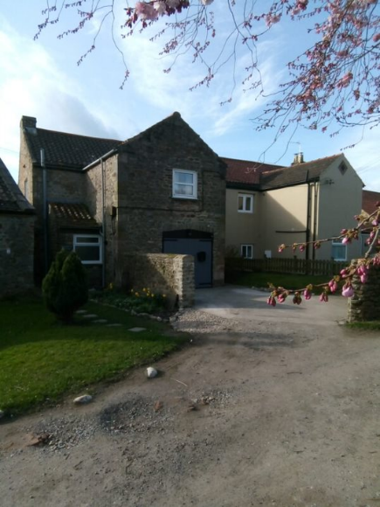

- Parking is on the drive, which is located 6m from the main entrance. Parking is free. Parking for 2 cars
- There is on-street parking within walking distance of the cottage.
- The car parking area is levelled concrete with a very slight slope.
- From the parking to the main entrance, there are no steps.

Arrival
Path to main entrance
- The path from street to the main entrance is an untarmacked road with some cobbles.

Key Safe
- Key safe is located at a height of 130cm

Main entrance
- The main door is side hung and manual.
- The entrance to the cottage at the front has 1 small step 14cm high, 11cm deep, 40cm wide.
- The door is 80cm wide with the keyhole 80cm high
- The outside lights are automatic but are also controlled by a light switch next to the door inside of the house.
- Details of location of the keys will be sent to you prior to your holiday.

Rear Entrance
- Access from the driveway
- Small step of 6cm
- The door is 80cm wide with the keyhole 96cm high
- The outside lights are automatic but are also controlled by a light switch next to the door inside of the house.

Getting around inside

- Stairs lead from the hallway to the first floor bedrooms and bathroom. The stairs are 18cm high and 24cm deep. There is a single hand rail.
- Heating is gas central heating throughout. There is a wood burner in the lounge, and radiators in each of the rooms.
- There are no level changes on the ground floor

Bedrooms
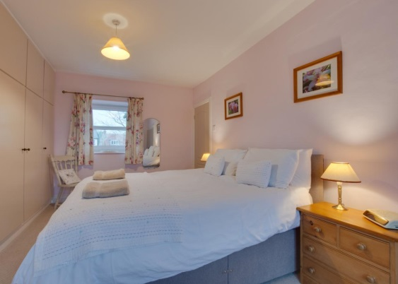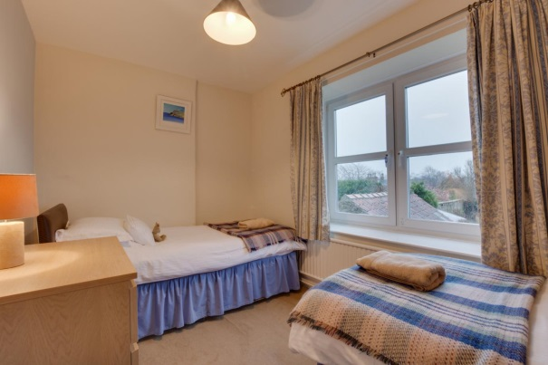

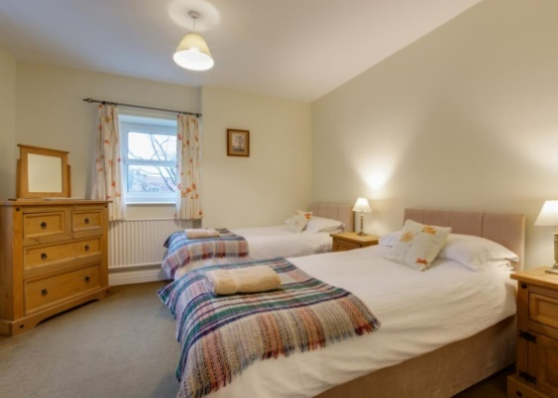
- All bedrooms have windows
- All bedrooms are located on the 1st floor – there is no lift
- Bedrooms have ceiling lights and bedside lamps.
- Lights are halogen and LED.
- All bedrooms are non-smoking.
- All bedrooms have fitted carpets.
- Door widths 76cm.
- King size bed provided – 5ft x 6ft 6in (150cm x 198cm)
- Single beds in 2 rooms – 3ft x 6ft 3in (91cm x 190cm)
- Bed height 65cm from floor to top of mattress (king size bed)
- Non-feather duvets and pillows provided.
- Largest transfer space available left or right of bed is 2 square metres.

Bathroom
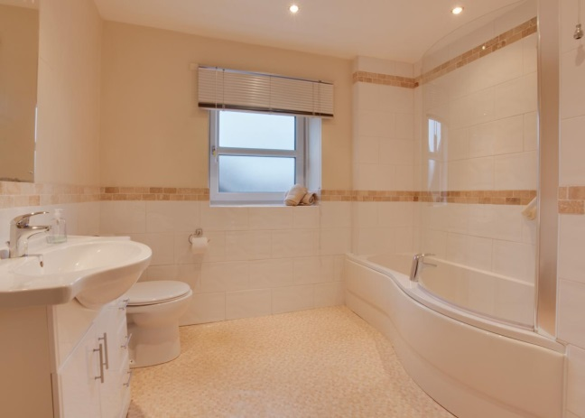
- The main bathroom is located on the 1st floor – there is no lift
- The shower is over the bath. There is a handrail.
- There is also a toilet on the ground floor, located off the garage

Kitchen
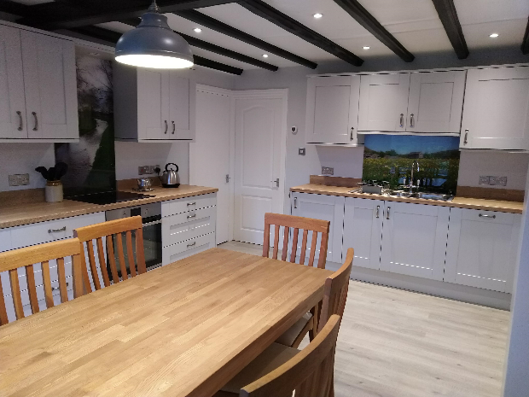

- Kitchen area is on the ground floor
- The worktop height is standard approximately 90cm.
- Oven door is traditional opening with hob above which is halogen at standard height.
- Sink is standard height with cupboards underneath.
- Standard size front loading washing machine and tumble dryer are provided in the snug.
- Lighting is spotlight bulbs on ceiling.
- Minimum of 80cm space between all furniture and worktops.
- Good contrast between floor, cupboards and other surfaces.
- Fridge/ freezer available.
- Microwave available at a approx. 150cm height.
- Flooring is laminate floor covering.
- Smoke alarm fitted in hallway.
- Carbon monoxide alarms are fitted in the kitchen and lounge

Lounge
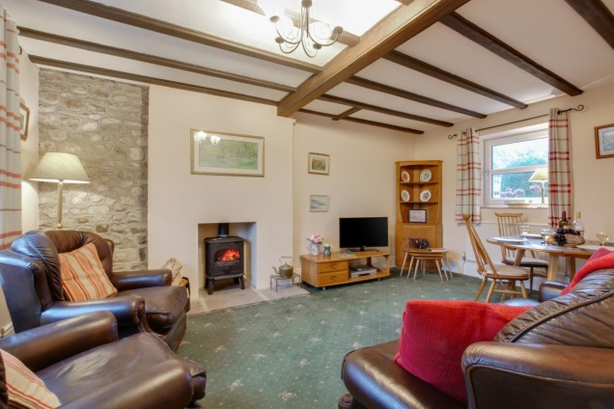

- The door is 76cm wide
- The Lounge is located on the ground floor
- There is a free space of 70cm clear of doors and furniture.
- Flooring is carpet.
- Furniture is moveable.
- One fabric covered sofa and three arm chairs.
- TV with remote control. Freeview, DVD player and video player.

Getting around outside

Garden
- From the main entrance to the area, there is 1 step into the garden.
- Garden is level with paved footpath
- There is a cobble path along the side of the property

